Chapter 2 Forces and vectors
Short investigation 2.1: Weight and mass
Name:
Aim
To examine the relationship between weight and mass
Materials
10 × 50 g masses (usually sold as a set with a suspender base), 5-newton spring scale, retort stand, clamp and boss head
Method
- Assemble the retort stand with clamp and boss head.
- Calibrate the spring scale. This is usually done by pulling or pushing the metal tag at the top of the scale until the indicator is aligned with the zero mark. For some scales, you will need to twist an adjustment screw (usually also at the top of the scale).
- Hang the calibrated scale from the clamp of the retort stand.
- Suspend a 50 g mass from the scale hook. Read the spring scale and enter the weight registered in table 2.1A.
- Repeat step 4 with masses of 100 g, 150g and so on up to 500 g.
Results
Table 2.1A
Mass (g) | Mass (kg) | Weight (N)
50
100
150
200
250
300
350
400
450
500
Analysing the results
- On the graph section below, plot the results that you have entered in table 2.1A, ensuring that the mass (in kg) is on the horizontal axis and weight (in N) is on the vertical axis. Draw a line of best fit through your results.
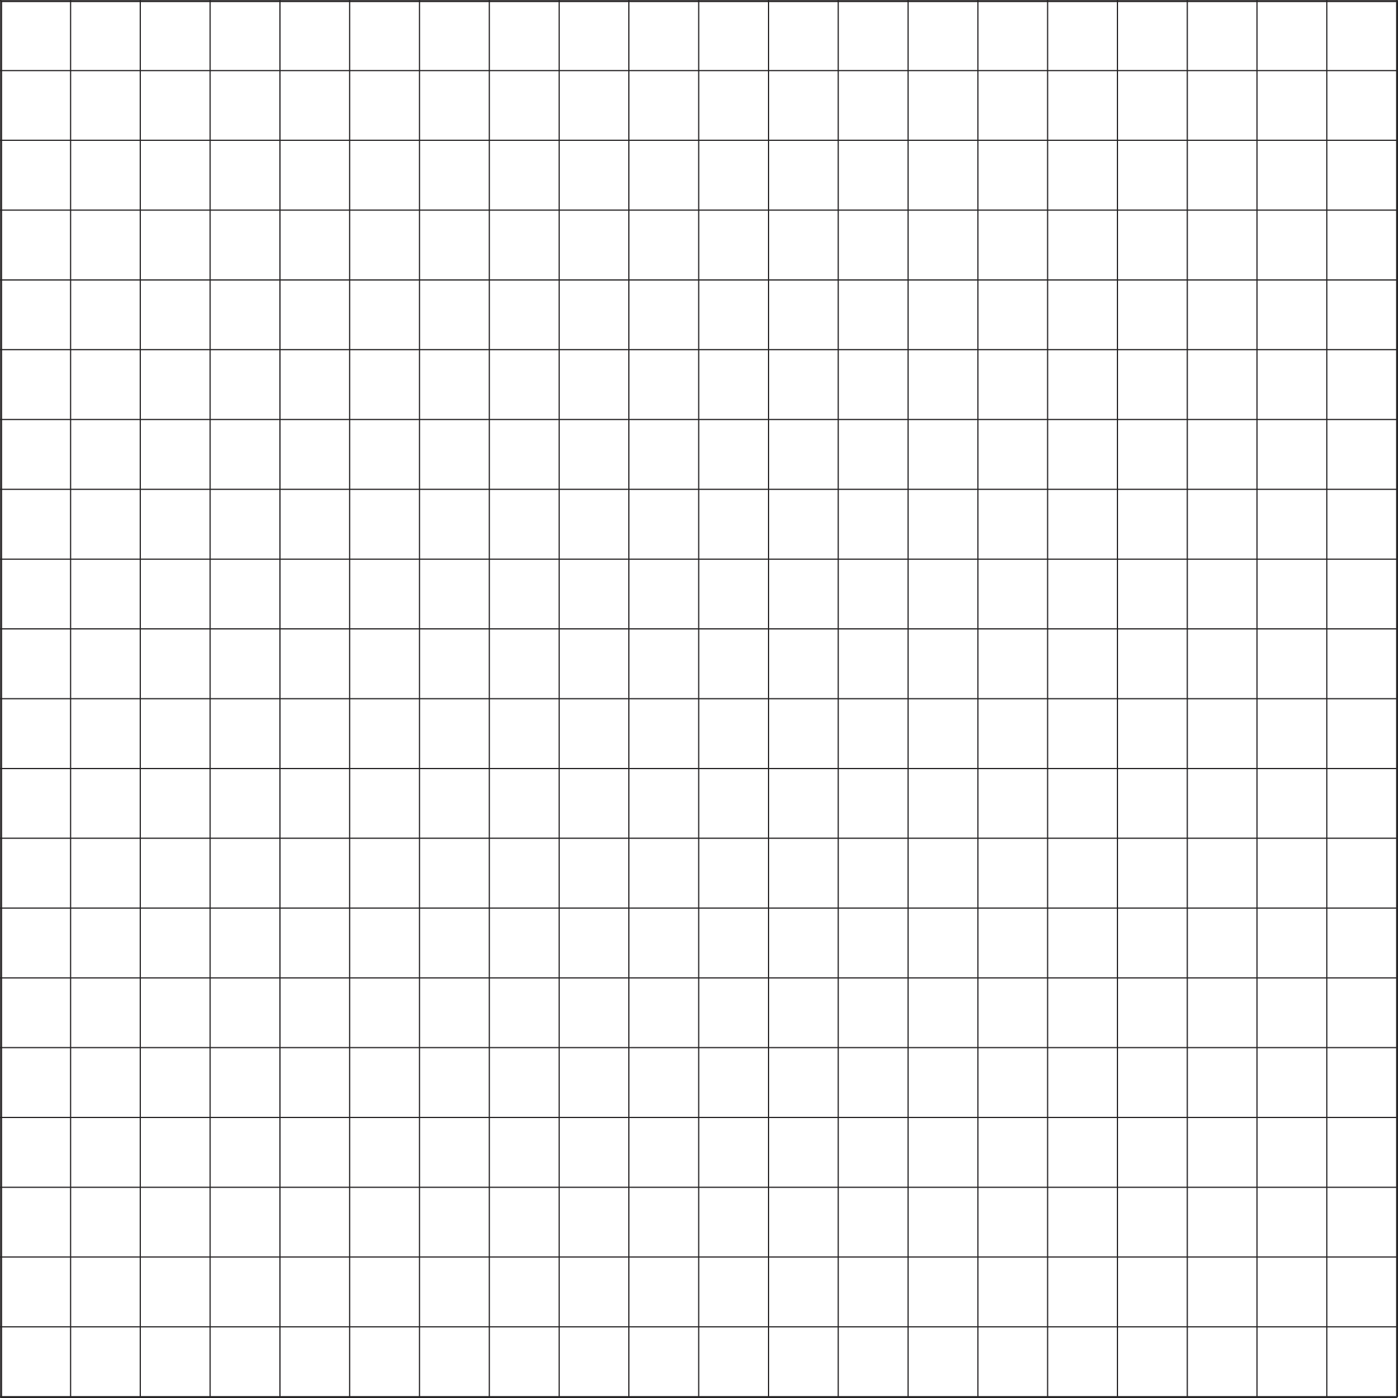
Determine the gradient of the line of best fit.
- Weight (w) and mass (m) are related by the equation w = mg, where g is the acceleration due to gravity in m s^{–2}; its value will be the gradient that you calculated above. On average, this value should be 9.81 m s^{–2}.
Calculate the % error in your determination of g compared to the theoretical value of
9.81 m s^{–2}:
% error = $\left|\frac{\text{theoretical} \text{value} − \text{experimental} \text{value}}{\text{theoretical} \text{value}}\right| × \text{100} \text{\%}$
- What explanations can you give for any discrepancy between your investigational value and the theoretical value?
Conclusion
What have you found out about the relationship between weight and mass in this investigation?
Notes:

